# **Mehnati Mobile App User Guide**

## **Table of Contents**

1. Introduction
2. Getting Started
   * Installation
   * Account Setup
3. Navigating the App
   * Main Screen
   * Bottom Navigation Bar
4. Using the App
   * Home Page
   * Messages
   * Viewing and Managing Bookings
   * Notifications
   * Profile
   * Edit profile
   * Booking process
   * Service provider profile
   * Booking
5. Advanced Features
   * Adding and Managing Locations
6. Frequently Asked Questions
7. Contacting Support

## **1. Introduction**

Welcome to Mehanti, your all-in-one platform for booking a wide range of services online. Whether you need carpentry work, car services, plumbing assistance, or any other professional service, Mehanti connects you with skilled service providers in your area.

This comprehensive guide will walk you through every aspect of the Mehanti app, from installation to advanced features. By the end of this guide, you'll be equipped to make the most of Mehanti's convenient and user-friendly interface.

## **2. Getting Started**

### **2.1 Installation**

To begin your Mehanti experience, you'll need to install the app on your smartphone. Follow these step-by-step instructions based on your device:

#### **For Android Devices:**

1. Open the Google Play Store on your Android device.
2. In the search bar at the top, type "Mehanti".
3. From the search results, locate the official Mehanti app.
4. Tap the "Install" button.
5. Wait for the download and installation to complete.
6. Once installed, tap "Open" to launch the app.

#### **For iOS Devices:**

1. Open the App Store on your iPhone or iPad.
2. Tap the search icon (magnifying glass) at the bottom.
3. In the search bar, type "Mehanti".
4. From the search results, find the official Mehanti app.
5. Tap "Get" and then "Install".
6. You may need to confirm the installation with Face ID, Touch ID, or your Apple ID password.
7. Once the installation is complete, tap "Open" to launch the app.

### **2.2 Account Setup**

After installing the app, you'll need to set up your account. Follow these steps:

1. Open the Mehanti app on your device.
2. On the welcome screen, tap "Get Started" or "Sign Up".
3. Enter your mobile phone number in the provided field.
4. Tap "Send OTP" (One-Time Password).
5. You'll receive an SMS with a 6-digit verification code.
6. Enter this code in the app when prompted.
7. If the code is correct, you'll be asked to complete your profile:
   * Enter your full name
   * Provide your email address (optional but recommended for account recovery)
   * Upload a profile picture (optional)
8. Review and accept the Terms of Service and Privacy Policy.
9. Tap "Complete Profile" or "Finish".

Congratulations! Your Mehanti account is now set up and ready to use.

## **3. Navigating the App**

### **3.1 Main Screen**

#### 

Upon logging into Mehanti, you'll be greeted with the main screen, which is designed for easy navigation and quick access to services. Here's a detailed breakdown of what you'll see:

* **Location Manager**: At the top of the screen, you'll see your current location. Tap on it to change or update your location.
* **Welcome Message**: Just below the location, you'll see a personalized greeting, such as "Hello, [Your Name]."
* **Search Bar**: A prominent search bar allows you to quickly find specific services or service providers. Tap on it and type keywords related to the service you need.
* **Promotional Banner**: This sliding banner showcases current promotions, featured services, or important announcements. Swipe left or right to view different promotions.
* **Category Shortcuts**: Below the banner, you'll find circular icons representing different service categories (e.g., Plumbing, Electrical, Cleaning). Tap on these for quick access to specific service types.
* **Cart Icon**: Located in the top-right corner, this icon allows you to view and manage items in your cart.
* **Contractors Section**: This section displays a list of available contractors. You can scroll horizontally to view more.
* **Nearby Service Providers**: Here you'll find service providers located close to your current location.
* **Featured Section**: This area highlights special offers or highly-rated service providers.
* **Popular Service Providers**: A list of the most frequently booked or top-rated service providers in your area.

### **3.2 Bottom Navigation Bar**

The bottom navigation bar is your main tool for moving between different sections of the app. It contains five icons:

1. **Home Icon**: This house-shaped icon takes you back to the main screen from anywhere in the app.
2. **Messages Icon**: Represented by a chat bubble, this icon leads you to your messages screen where you can communicate with service providers.
3. **Appointments Icon**: This calendar-like icon takes you to your bookings screen, where you can view and manage your scheduled services.
4. **Notifications Icon**: Shaped like a bell, this icon leads to your notifications screen, showing you updates about your bookings, promotions, and other important information.
5. **Profile Icon**: This human-shaped icon takes you to your profile screen, where you can manage your account settings and personal information.

## **4. Using the App**

### **4.1 Home Page**

#### 

The home page is your starting point for finding and booking services. Here's how to make the most of it:

1. **Using the Search Bar**:
   * Tap on the search bar at the top of the screen.
   * Type in the service you're looking for (e.g., "plumber", "house cleaning").
   * As you type, you'll see suggested services appear below. You can tap on one of these or complete your search.
   * Press the search icon or "Enter" on your keyboard to see the full results.
2. **Browsing Categories**:
   * Scroll through the category icons to find the type of service you need.
   * Tap on a category to see all services and providers within that category.
3. **Exploring Featured and Popular Sections**:
   * Scroll down to view featured offers and popular service providers.
   * Tap on any provider to view their profile, services, and booking options.
4. **Using Filters**:
   * When viewing search results or category listings, look for a "Filter" option, usually represented by a funnel icon.
   * Tap this to refine your search by factors such as price range, rating, availability, and more.
5. **Booking a Service**:
   * Once you've found a service provider you'd like to book, tap on their listing.
   * Review their profile, services offered, pricing, and availability.
   * Select the specific service you want and your preferred date and time.
   * Tap "Book Now" or "Add to Cart" to proceed with your booking.

### **4.2 Messages**

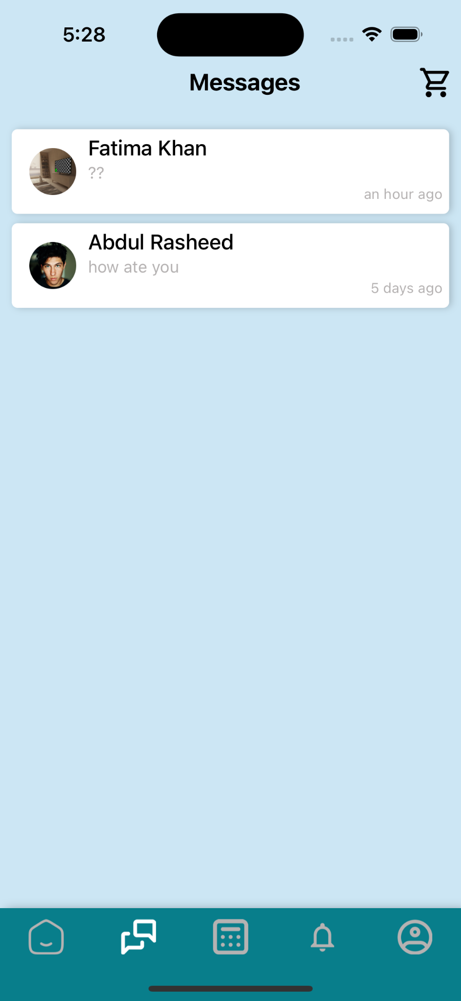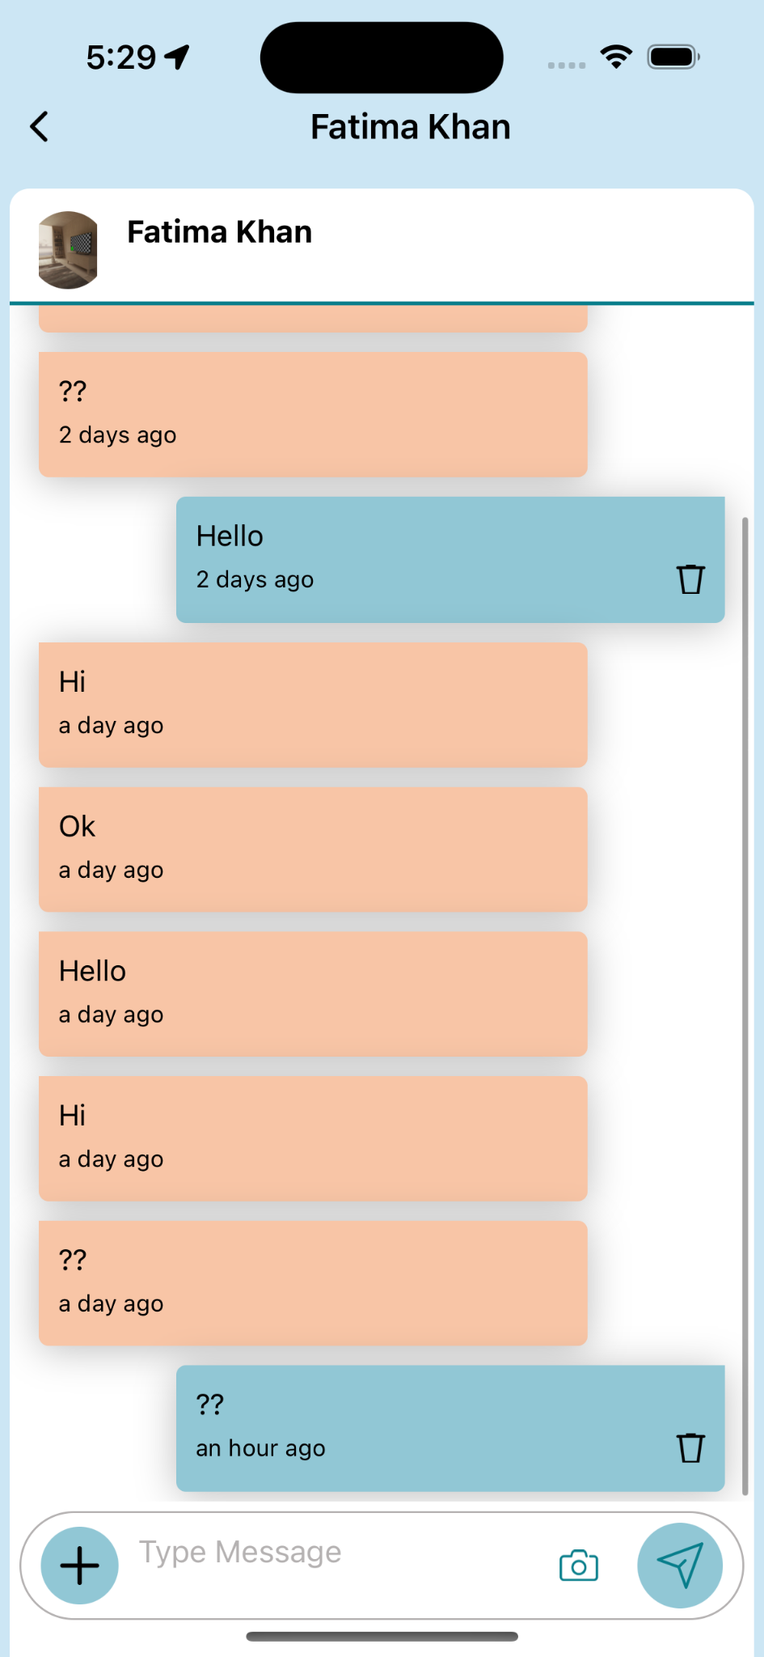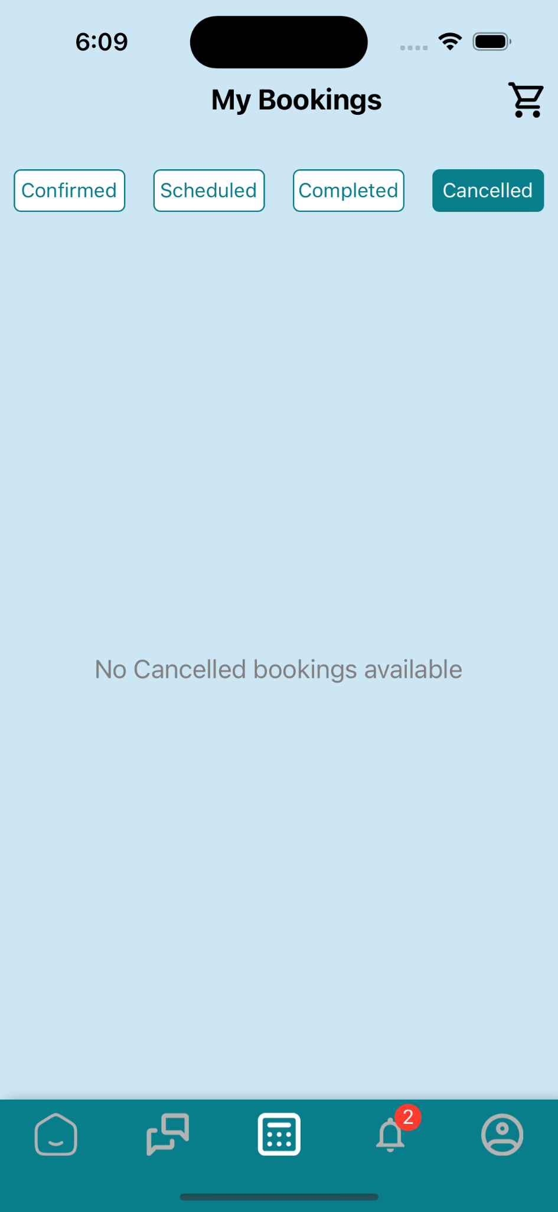

The Messages screen is your hub for communication within the app. Here's a detailed guide on how to use it:

#### **Accessing the Messages Screen**

1. Tap the Messages icon (chat bubble) in the bottom navigation bar.
2. You'll see a list of all your conversations, including those with service providers and Mehanti support.

#### **Conversation List**

* Each conversation in the list shows:
  + The name of the service provider or "Mehanti Support"
  + A preview of the last message
  + The time or date of the last message
* Unread messages are indicated by a bold font and a red dot with the number of unread messages.

#### **Starting a New Conversation**

* Generally, new conversations are initiated when you book a service.
* If you need to contact Mehanti support, look for a "Contact Support" or "Help" option in your profile or settings.

#### **Viewing and Replying to Messages**

1. Tap on any conversation in the list to open it.
2. You'll see the full message thread with the service provider or support team.
3. To reply:
   * Tap the text field at the bottom of the screen.
   * Type your message.
   * Tap the send button (usually a paper airplane icon) to send your message.

#### **Attaching Files or Images**

1. In an open conversation, look for a paperclip or camera icon near the text field.
2. Tap this icon to open your device's file browser or camera.
3. Select the file you want to send or take a new photo.
4. Add a caption if desired, then tap send.

#### **Deleting Messages or Conversations**

* To delete a single message: Long-press on the message, then select "Delete" from the options that appear.
* To delete an entire conversation: From the main Messages screen, swipe left on the conversation and tap "Delete".

### **4.3 Viewing and Managing Bookings**

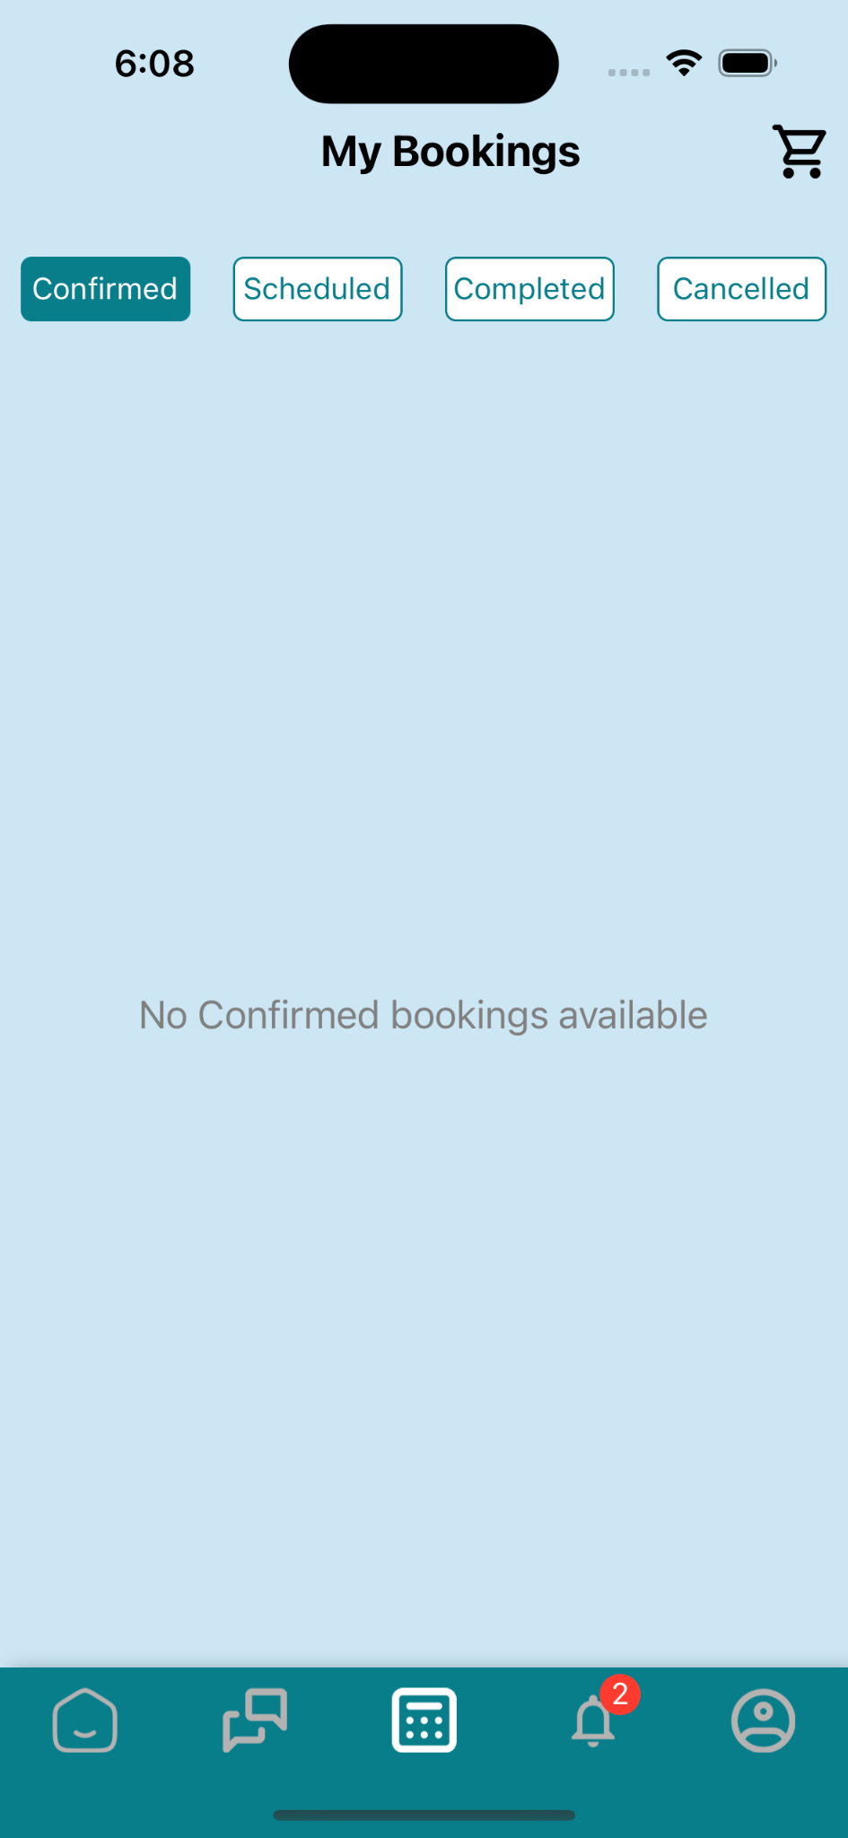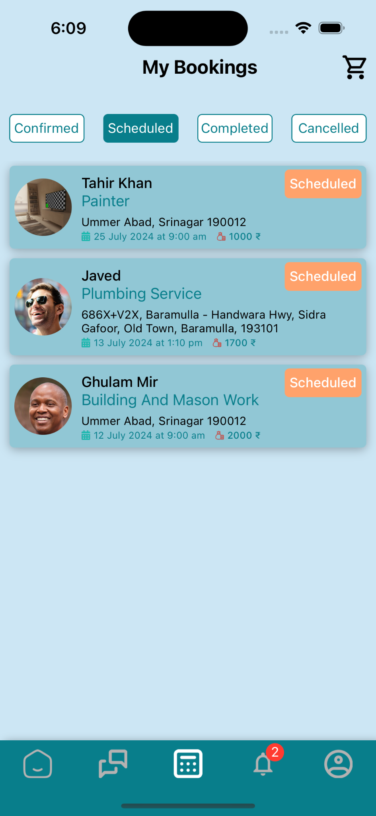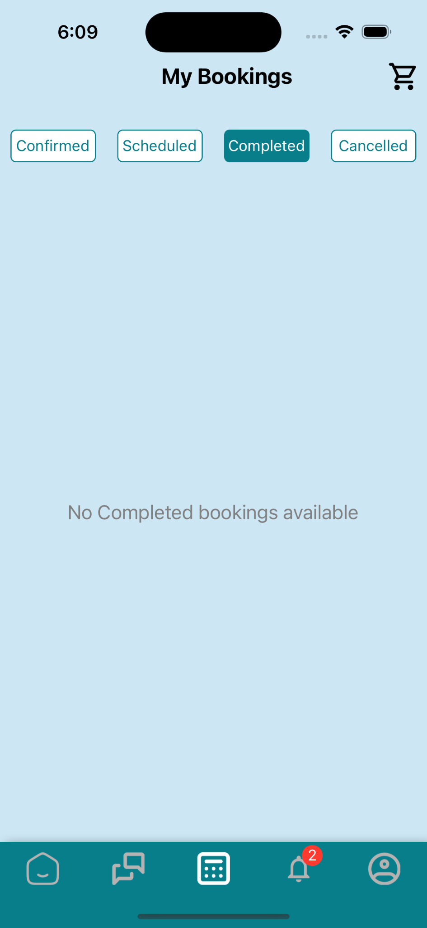

The Bookings screen helps you keep track of all your service appointments. Here's how to use it effectively:

#### **Accessing the Bookings Screen**

1. Tap the Appointments icon (calendar) in the bottom navigation bar.
2. Your bookings are organized into four tabs: Scheduled, Confirmed, Completed, and Canceled.

#### **Understanding Booking Statuses**

1. **Scheduled**: These are bookings you've made but still need to be confirmed by the service provider.
2. **Confirmed**: These bookings have been accepted and confirmed by the service provider.
3. **Completed**: These services have been carried out and marked as complete.
4. **Canceled**: These are bookings that were canceled, either by you or the service provider.

#### **Viewing Booking Details**

1. Tap on any booking in the list to see its details.
2. You'll see information such as:
   * Service type
   * Service provider name
   * Date and time of the appointment
   * Status of the booking
   * Price (if applicable)
   * Address where the service will be performed

#### **Managing Your Bookings**

* **Canceling**: To cancel a booking, open the booking details and look for a "Cancel Booking" option. Follow the prompts to complete the cancellation.
* **Adding Notes**: Some bookings allow you to add notes for the service provider. Look for an "Add Note" or "Special Instructions" field.

#### **Tracking Ongoing Services**

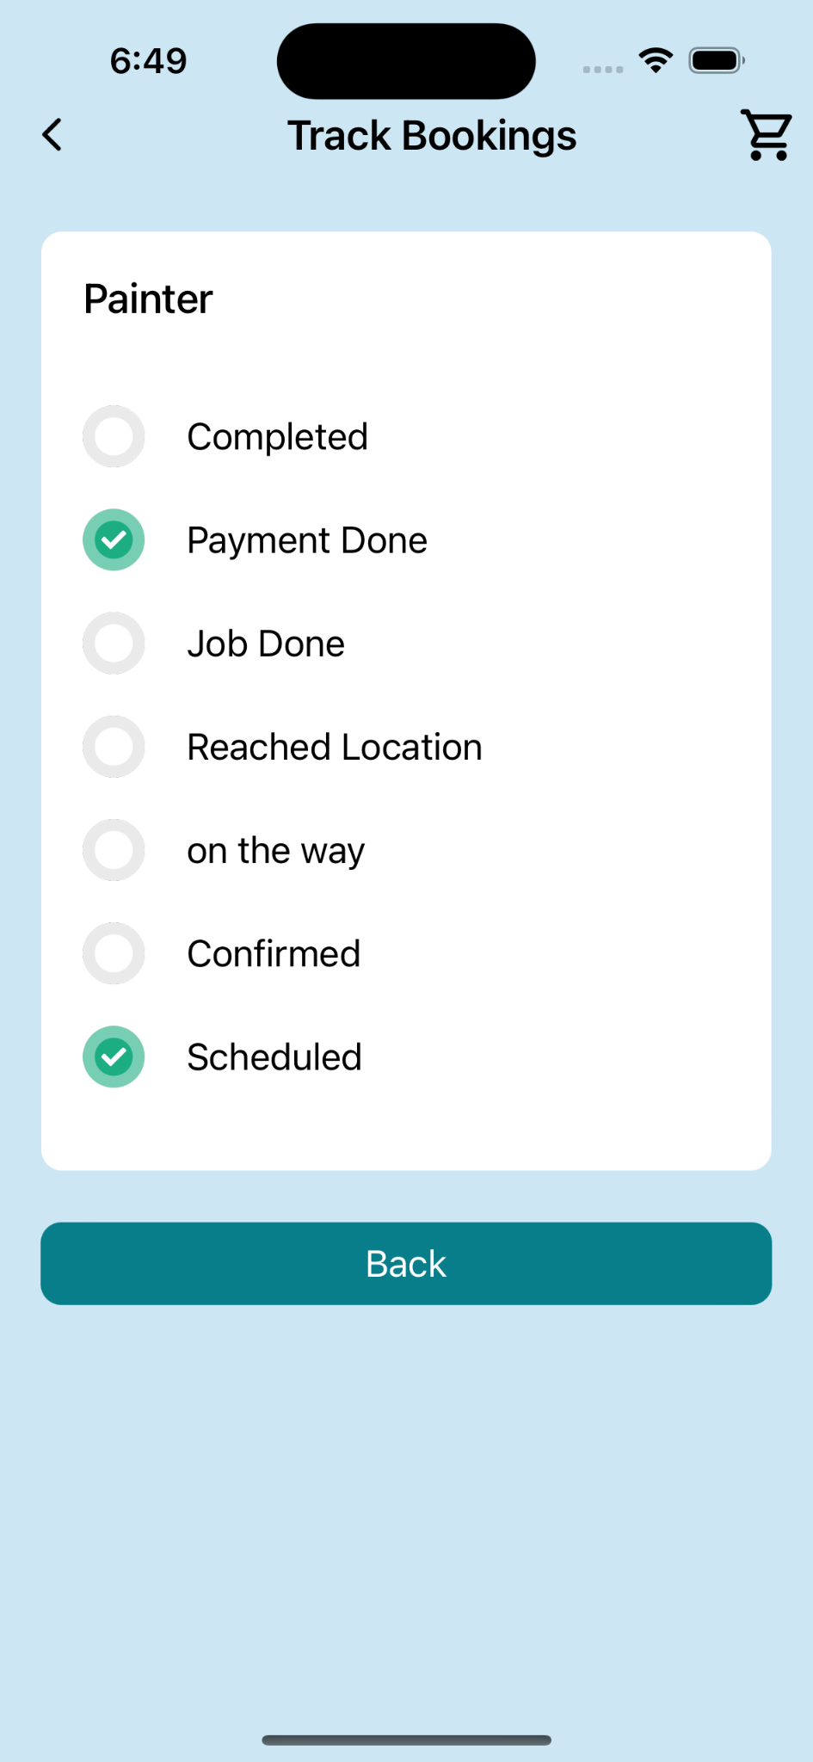

1. For services in progress, you may see a "Track" option on the booking.
2. Tap this to view real-time updates on the service provider's location or progress.

#### **Leaving Feedback**

1. After a service is completed, you'll be prompted to leave feedback.
2. Rate your experience (usually on a 5-star scale) and leave a written review if desired.
3. Your feedback helps maintain service quality and assists other users in choosing providers.

### **4.4 Notifications**

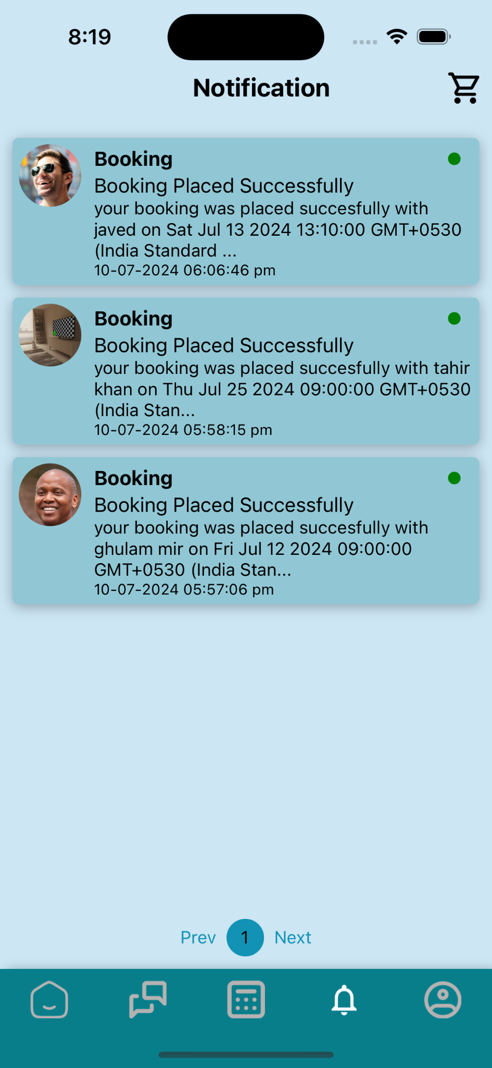

The Notifications screen keeps you updated on important events related to your bookings and account. Here's how to use it:

#### **Accessing Notifications**

1. Tap the Notifications icon (bell) in the bottom navigation bar.
2. You'll see a list of all your recent notifications.

#### **Types of Notifications**

You may receive notifications for:

* Booking confirmations
* Reminders about upcoming appointments
* Changes to your bookings (e.g., if a service provider reschedules)
* Special offers or promotions
* Updates to the app or your account

#### **Interacting with Notifications**

* + - 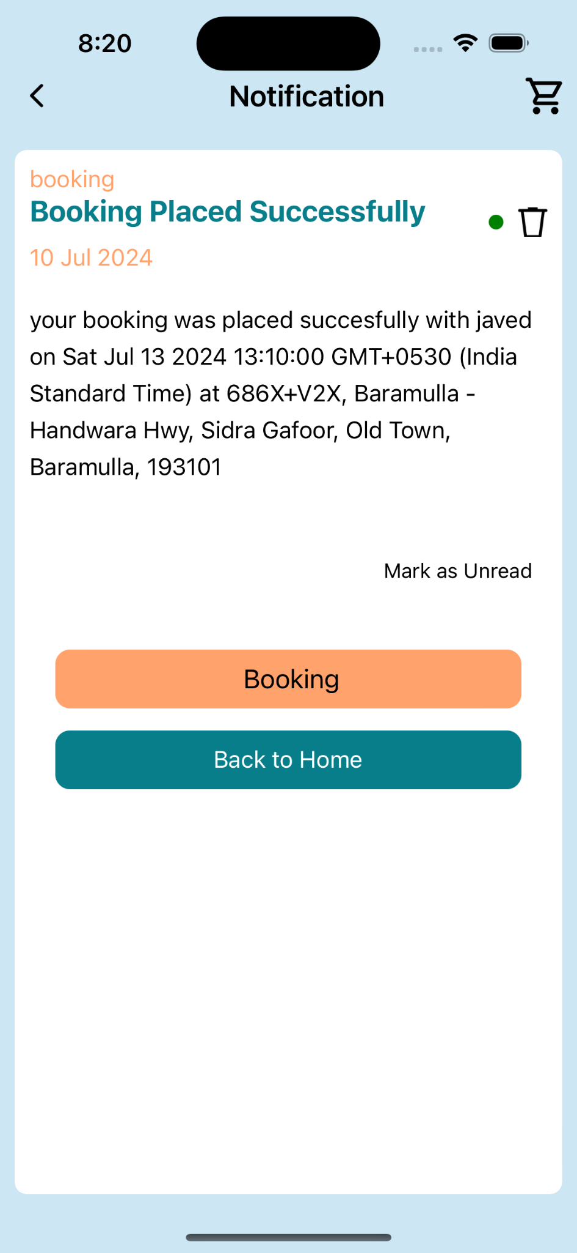

1. Tap on a notification to view more details or take action.
2. Some notifications may have buttons like "View Booking" or "Respond" that take you to the relevant part of the app.

#### **Managing Notifications**

1. To delete a single notification, swipe left on it and tap "Delete".
2. Look for a "Mark All as Read" option at the top of the screen to clear new notification indicators.
3. To adjust your notification settings:
   * Go to your Profile
   * Look for a "Settings" or "Preferences" option
   * Find "Notification Settings" and customize which notifications you receive

### **4.5 Profile**

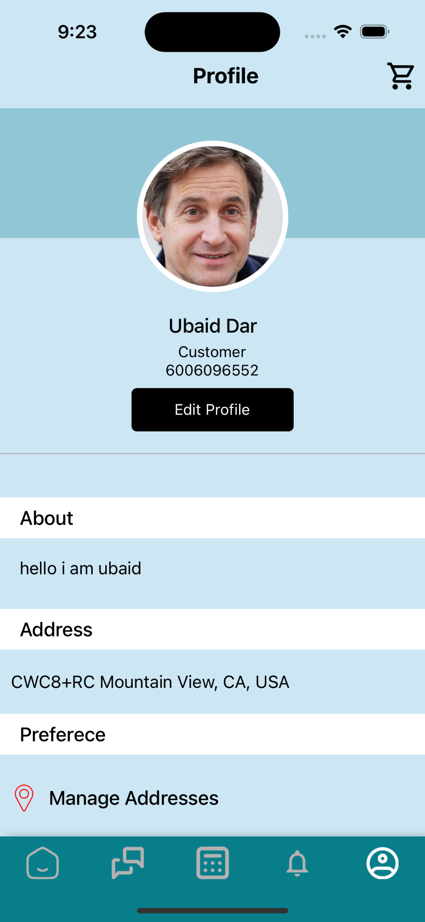

Your profile contains your personal information and account settings. Here's how to manage it:

#### **Accessing Your Profile**

1. Tap the Profile icon (person silhouette) in the bottom navigation bar.
2. You'll see your profile page with your picture, name, and customer number.

#### **Editing Your Profile**

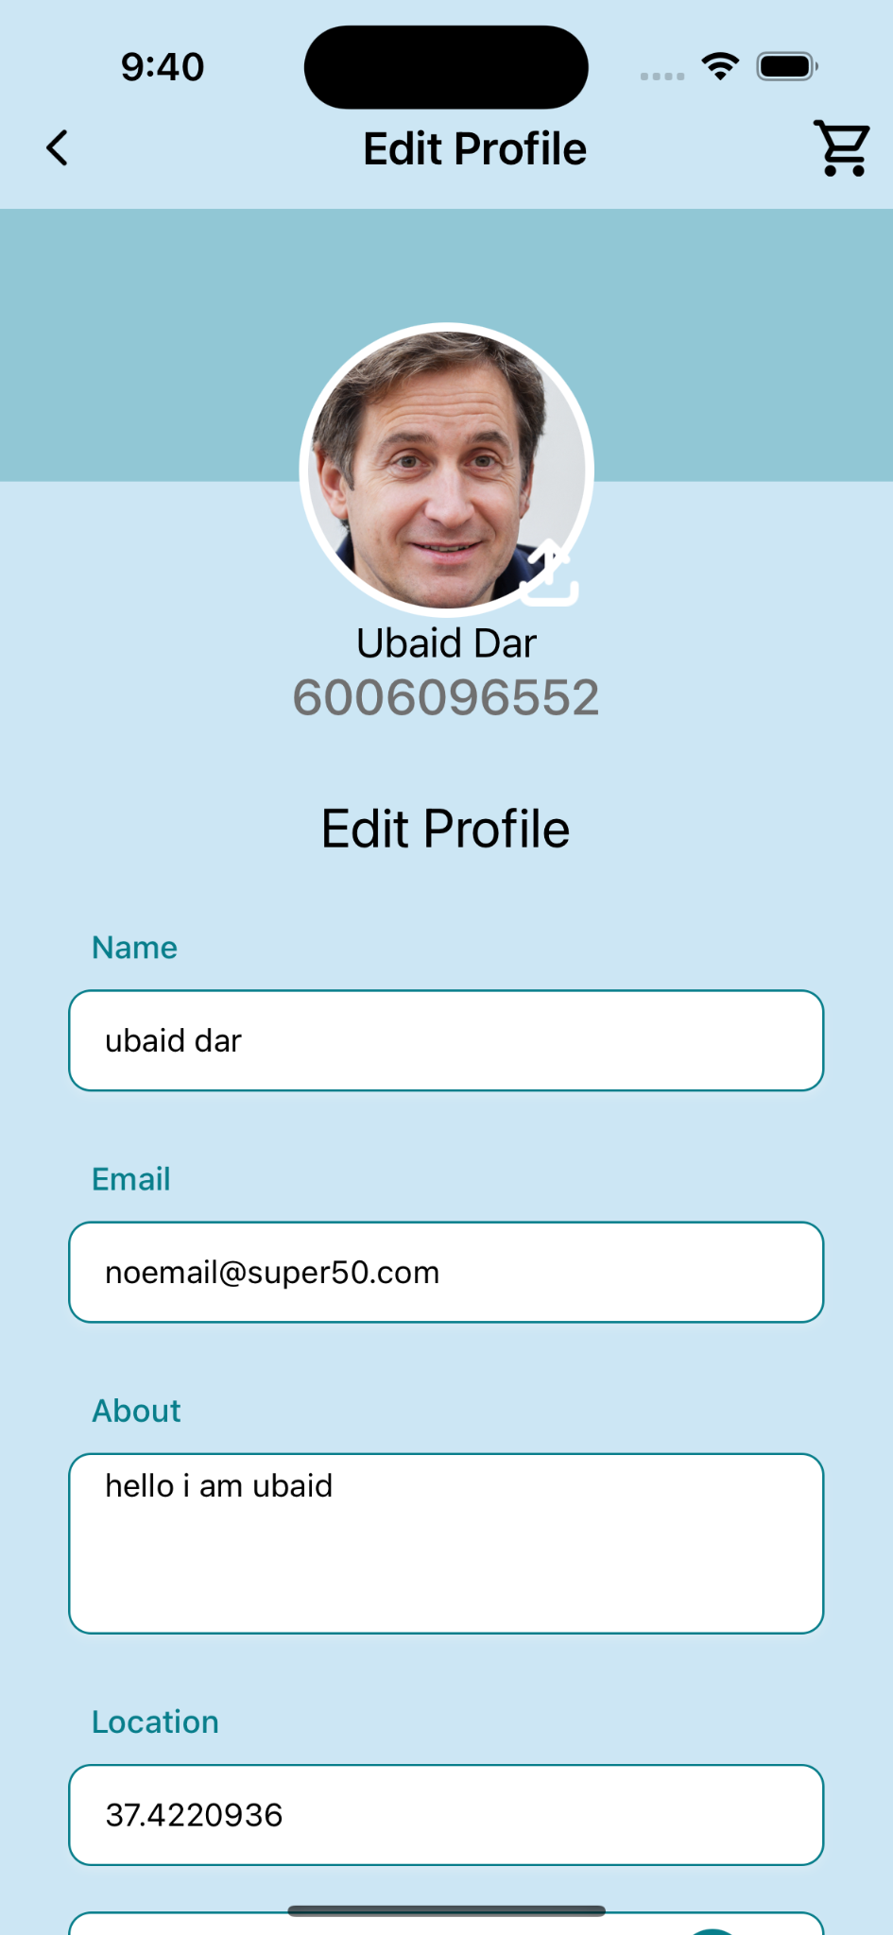

1. Tap the "Edit Profile" button.
2. You can modify:
   * Profile picture (tap the current picture to change it)
   * Name
   * Email address
   * Phone number (may require verification)
   * About section (a brief bio, if applicable)
3. After making changes, tap "Save" to update your profile.

#### **Managing Addresses**

1. In your profile, find the "Addresses" or "Manage Addresses" section.
2. Here you can:
   * View your saved addresses
   * Add a new address
   * Edit existing addresses
   * Delete addresses you no longer need

##### **Adding a New Address**

1. Tap "Add New Address" or a similar option.
2. You'll see a map where you can pinpoint your location.
3. Drag the map to position the pin accurately.
4. The address details will be automatically filled based on the pin location.
5. You can manually adjust any details if needed.
6. Tap "Save" to add the new address to your list.

#### **Preferences and Settings**

In your profile, you may find options to:

* Change your password
* Set your preferred language
* Adjust notification settings
* View terms and conditions
* Access help and support

#### **Logging Out**

1. Scroll to the bottom of your profile page.
2. Look for a "Log Out" button.
3. Tap it and confirm to log out of your account.

### **4.6 Service Provider Profile**

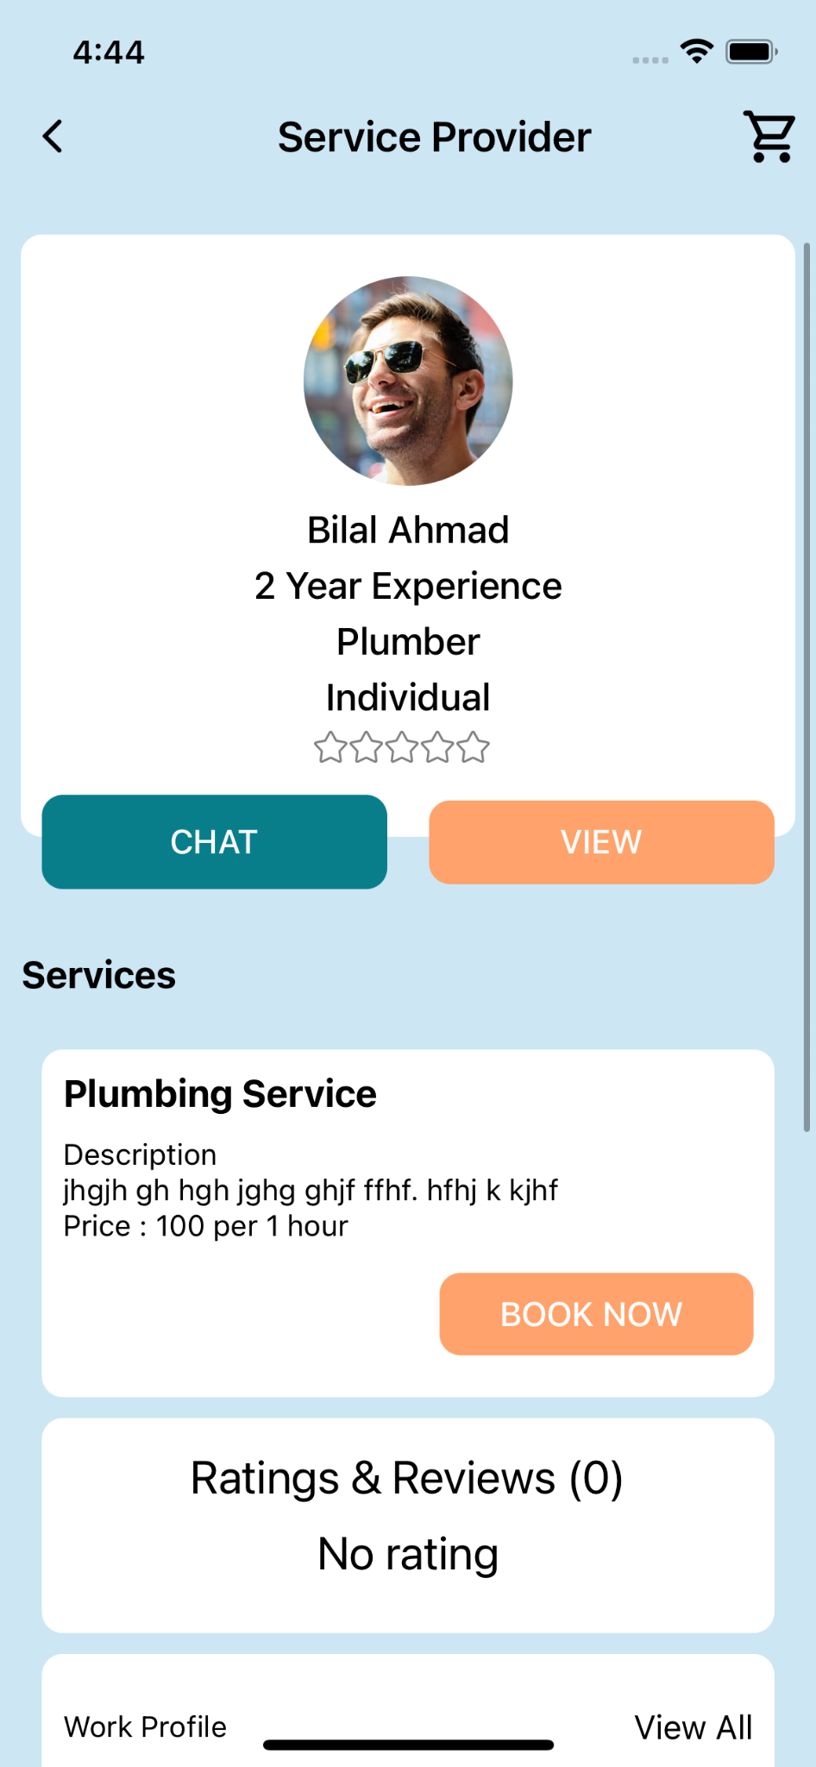

The Service Provider Profile contains detailed information about the service providers available on Mehanti. Here's a breakdown of what you can find in this profile:

* **Profile Picture of Service Provider**
* **Name**
* **Years of Experience**
* **Category Type**
* **Stars of Rating**

Underneath this information, you will find two buttons:

* **Chat:** Start a chat with the service provider.
* **View Profile:** View the complete profile of the service provider.

**Sections in the Profile:**

* **Service Provided:** A list of services offered by the provider, with a "Book Now" button for immediate booking.
* **Rating and Review Section:** Read and leave reviews about the service provider.
* **Work Profile:** Detailed work profile of the service provider.
* **Certificates:** Any certifications held by the service provider.
* **About Section:** Additional information about the service provider.

### **4.7 Booking**

The booking process in the Mehanti app involves multiple screens to ensure a smooth and detailed service booking experience. Below is the step-by-step guide:

**Step 1: Date and Time Selection**

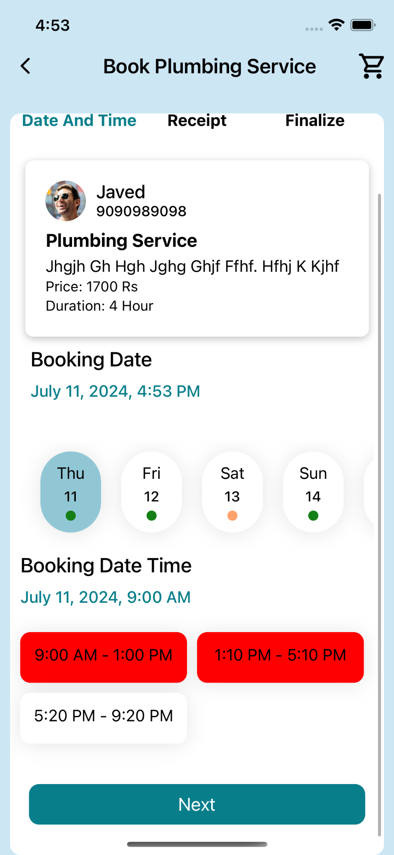

* **Screen:** Book Plumbing Service
* **Details:**
  + **Service Provider Information:** Displays the profile picture, name, phone number, and service details.
  + **Booking Date:** Users can select the date for the service.
  + **Booking Time Slots:** Available time slots for the selected date are shown. Users can select their preferred time slot.

**Step 2: Receipt Information**

* 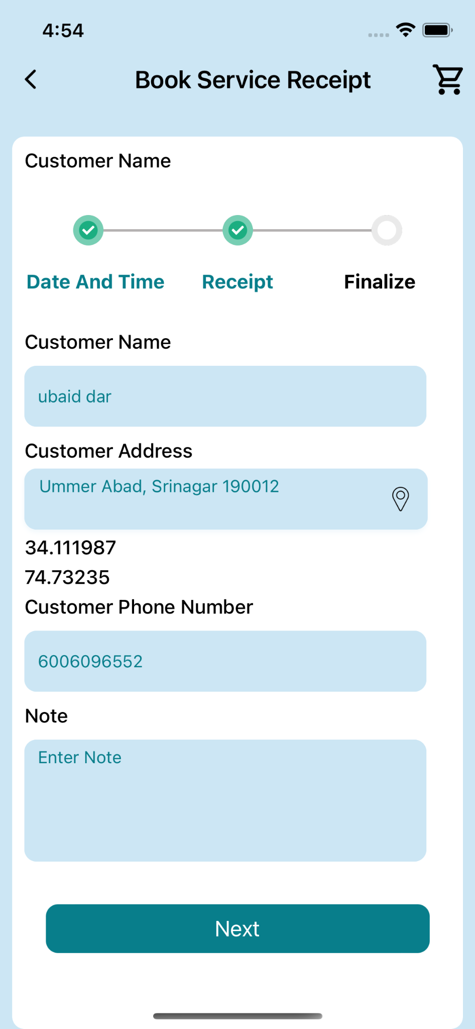
* **Screen:** Book Service Receipt
* **Details:**
  + **Customer Information:** Fields to enter the customer name, address, and phone number.
  + **Location Details:** Displayed address with latitude and longitude coordinates.
  + **Note:** Option to enter any specific notes for the service provider.

#### **Step 3: Finalize Booking**

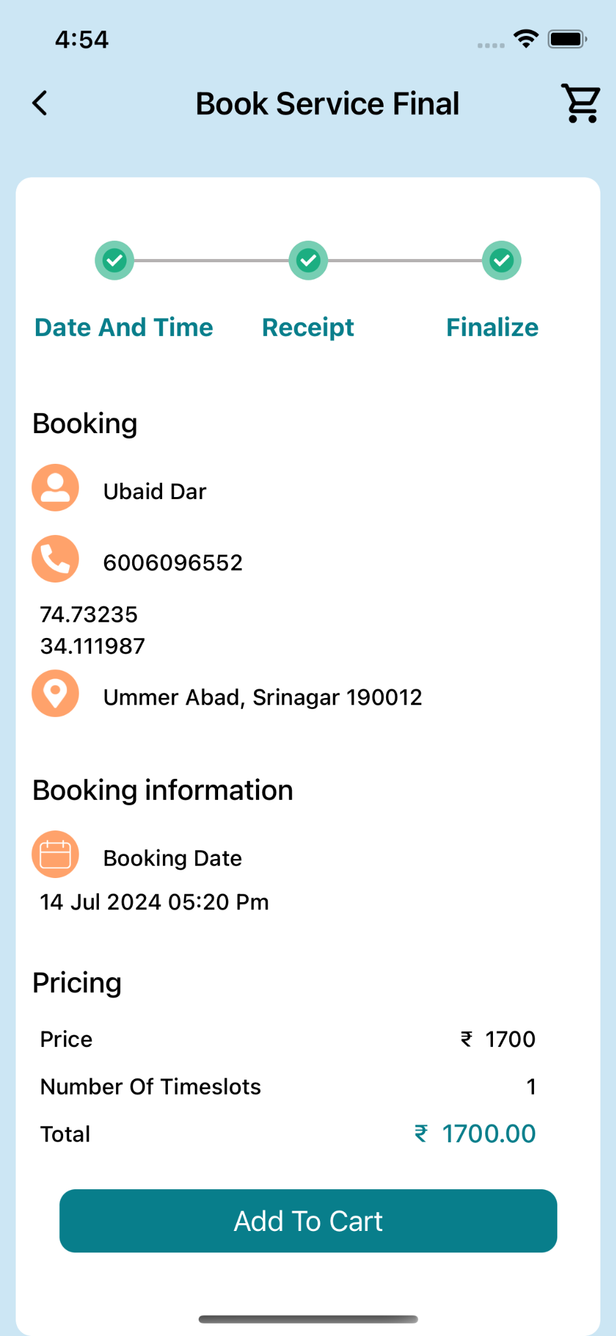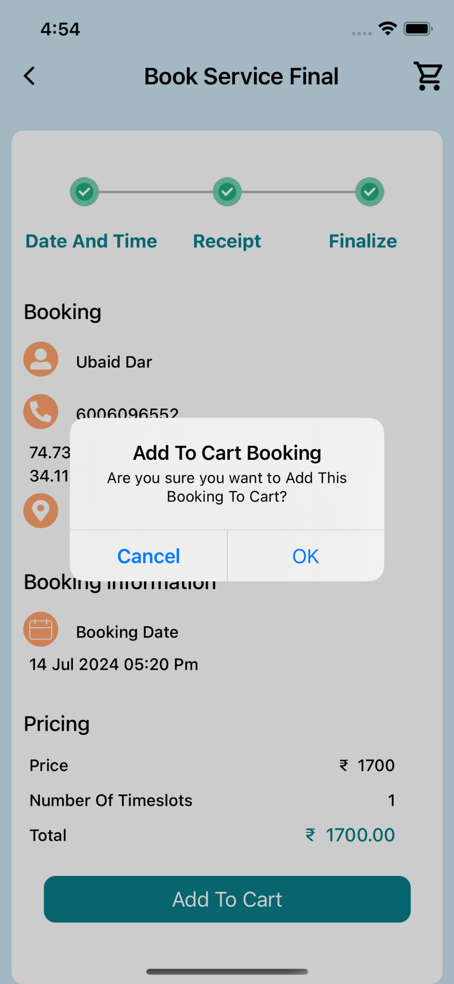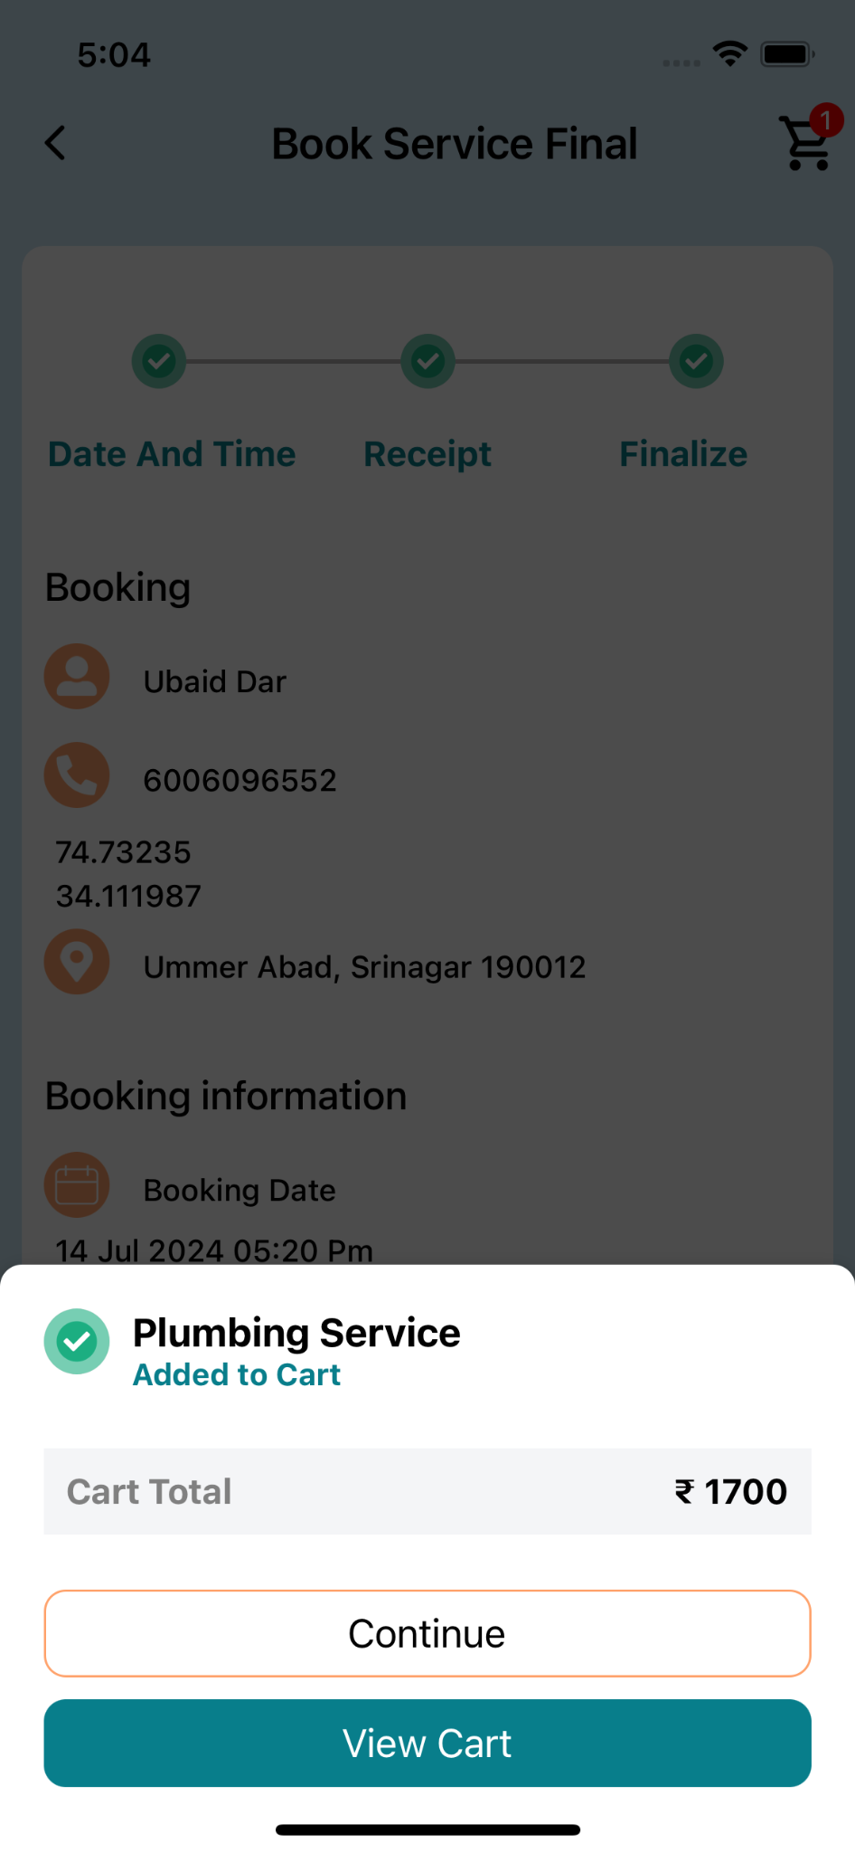

* **Screen:** Book Service Final
* **Details:**
  + **Summary of Booking:** Shows the customer name, contact number, coordinates, and address.
  + **Booking Information:** Includes the selected booking date and time.
  + **Pricing Details:** Displays the price per time slot and total amount.
  + **Action:** Button to add the booking to the cart for final confirmation and payment.

### **4.8 Cart**

The Cart screen displays the details of the service you've added to your cart and provides options to proceed with the booking or make changes.

#### Screen Layout

1. **Header**
   * Back button (<) on the top left to return to the previous screen
   * "Cart" title in the center
   * Shopping cart icon on the top right with a red notification badge (1)
2. **Service Details Card**
   * A white card containing all the information about the service in your cart
3. **Action Buttons**
   * Three buttons at the bottom of the screen for different actions

#### Service Details

The white card displays the following information:

1. **Customer Information**
   * Name: Ubaid Dar
   * Address: Ummer Abad, Srinagar 190012
   * Phone: 6006096552
2. **Booking Details**
   * Price: 1700.00 ₹
   * Date and Time: 14 July 2024 At 5:20 Pm
   * Duration: 4 Hours
3. **Service Provider Information**
   * Profile picture: A small circular image of the service provider
   * Name: Javed
   * Phone: 9090989098
4. **Service Information**
   * Service Type: Plumbing Service
   * Service Amount: 1700 ₹
   * Service Duration: 4 Hours
5. **Delete Option**
   * A red trash can icon in the top right corner of the card allows you to remove this item from your cart

#### Action Buttons

At the bottom of the screen, you'll find three buttons:

1. **Check Out**
   * A teal-colored button to proceed with the booking
2. **Reset Cart**
   * A teal-colored button to clear all items from your cart
3. **Return home**
   * A teal-colored button to go back to the home screen

#### How to Use the Cart Screen

1. **Review Your Booking**
   * Carefully check all the details on the white card to ensure they're correct
2. **Remove Item**
   * If you want to remove this service from your cart, tap the red trash can icon
3. **Proceed to Checkout**
   * If you're ready to book the service, tap the "Check Out" button
4. **Clear Your Cart**
   * If you want to start over, tap the "Reset Cart" button
5. **Return to Home Screen**
   * To continue browsing services, tap the "Return home" button
6. **Go Back**
   * To return to the previous screen, tap the back arrow (<) in the top left corner

### **4.9 Checkout**

The Checkout screen displays a summary of your booking details and provides options to complete the payment process.

#### Screen Layout

1. **Header**
   * Back button (<) on the top left to return to the previous screen
   * "Checkout" title in the center
   * Shopping cart icon on the top right with a red notification badge (1)
2. **Receipt Section**
   * Contains basic customer information
3. **Bookings Section**
   * Displays detailed information about the current booking
4. **Pricing Section**
   * Summarize the total cost of the booking
5. **Payment Buttons**
   * Two buttons at the bottom for different payment options

#### Receipt Section

A white card displaying:

* Customer Name: Ubaid Dar
* Phone Number: 6006096552

#### Bookings Section

A white card showing:

* Customer Name: Ubaid Dar
* Date and Time: July 14th 2024, 5:20 Pm
* Address: Ummer Abad, Srinagar 190012
* Phone Number: 6006096552
* Price: 1700.00 ₹

#### Pricing Section

A white card summarizing:

* Total number of bookings: 1
* Price: ₹ 1700
* Total: ₹ 1700

#### Payment Options

Two payment buttons are provided at the bottom of the screen:

1. **Pay ₹ 1700**
   * This button allows you to pay the full amount for the service.
   * Tapping this will process the payment for the entire booking cost.
2. **Pay ₹ 340**
   * This button represents a partial payment option, which is 20% of the total amount.
   * Tapping this will process a down payment or reservation fee.

#### How to Use the Checkout Screen

1. **Review Your Booking Details**
   * Carefully check all the information in the Receipt and Bookings sections to ensure accuracy.
2. **Verify the Total Cost**
   * Confirm that the pricing in the Pricing section matches your expected total.
3. **Choose Your Payment Option**
   * Full Payment: If you're ready to pay the entire amount, tap the "Pay ₹ 1700" button.
   * Partial Payment: If you prefer to pay a 20% down payment now, tap the "Pay ₹ 340" button.
4. **Complete the Payment**
   * After selecting your payment option, you'll likely be directed to a payment gateway to finalize the transaction.
5. **Go Back**
   * If you need to make changes, tap the back arrow (<) in the top left corner to return to the previous screen.

#### Important Notes

* The ₹ 340 payment option represents a 20% down payment of the total service cost.
* Choosing the partial payment option may have implications on the booking process or cancellation policy. It's advisable to check the terms and conditions regarding partial payments.
* Ensure you understand the implications of each payment option before proceeding.
* If you have any questions about the payment options or need to make changes to your booking, it's recommended to contact customer support before completing the payment.

#### Payment Process

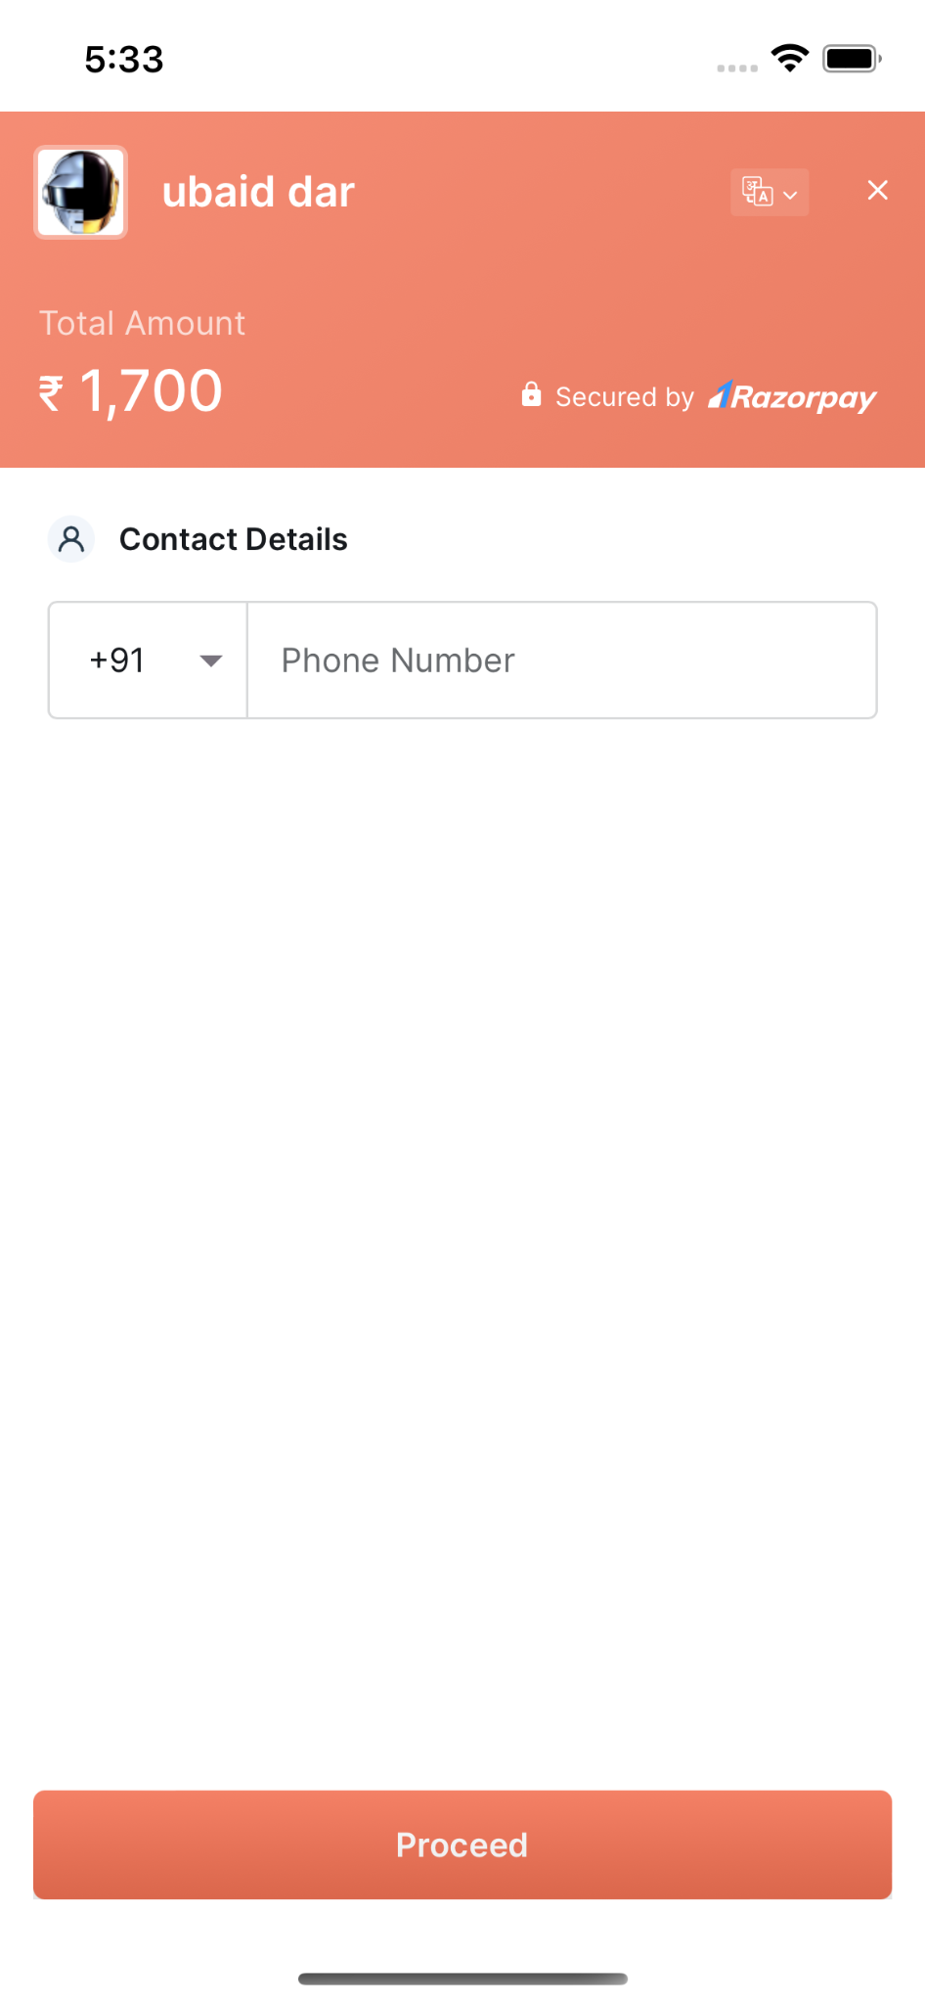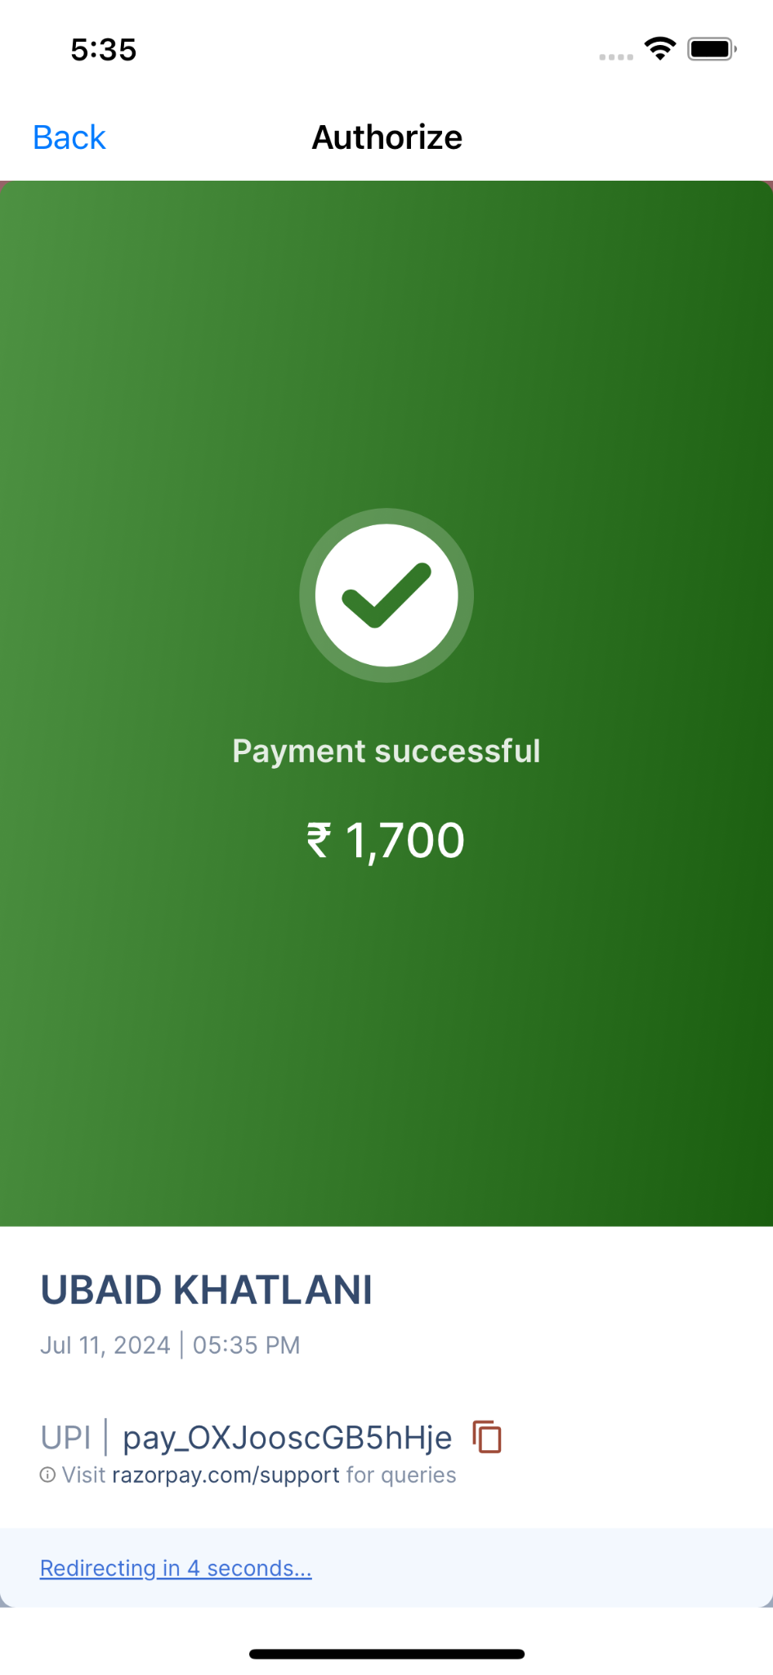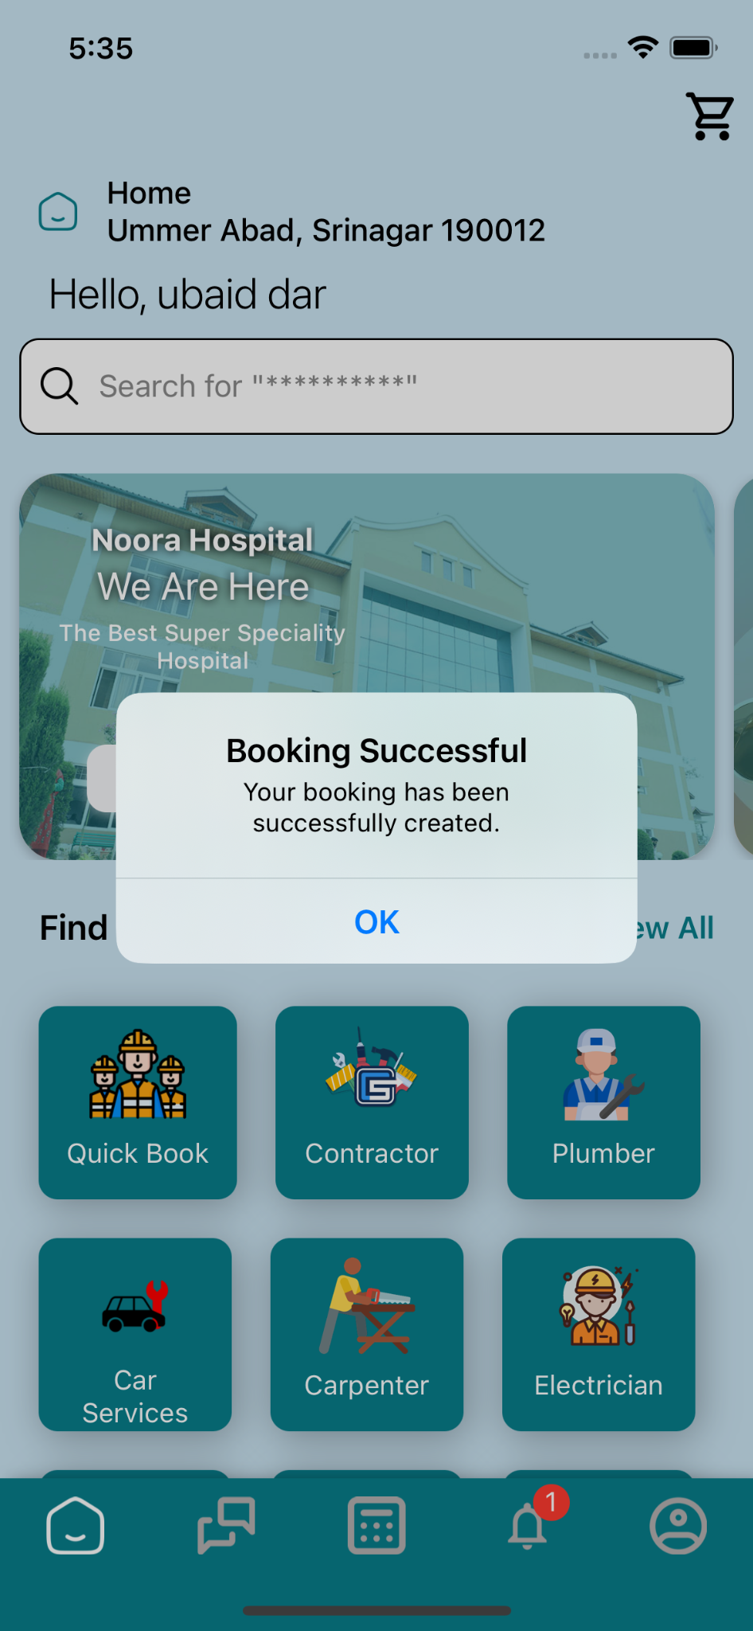

After reviewing your booking details and selecting your preferred payment option, the following steps will occur:

1. **Select Payment Option**
   * Tap either the "Pay ₹ 1700" button for full payment or "Pay ₹ 340" for the 20% partial payment.
2. **Razorpay Integration**
   * Upon tapping a payment button, the Razorpay payment gateway will open within the app.
3. **Payment Methods** Razorpay offers several payment options: a) UPI (Unified Payments Interface)
   * Select your preferred UPI app (e.g., Google Pay, PhonePe, Paytm)
   * Enter your UPI ID or scan the QR code
   * Complete the payment in your UPI app
4. b) Debit Card
   * Enter your debit card details (card number, expiry date, CVV)
   * You may need to complete a 3D Secure verification process
5. c) Credit Card
   * Enter your credit card details (card number, expiry date, CVV)
   * Complete any additional security steps required by your bank
6. **Payment Confirmation**
   * After successful payment, Razorpay will display a confirmation screen.
   * You'll be redirected back to the Mehanti app, where you'll see a booking confirmation.
7. **Transaction Failure**
   * If the payment fails for any reason, you'll be notified and given the option to try again or choose a different payment method.

#### Important Notes

* Ensure you have the necessary UPI apps installed or your card details ready before initiating payment.
* The Razorpay gateway is secure and compliant with payment industry standards.
* For any payment-related issues, you may need to contact both Mehanti customer support and your bank or UPI service provider.
* Keep your transaction ID (provided by Razorpay) for future reference or in case you need to follow up on the payment.

The Search screen allows users to find specific service providers or browse through different service categories. It provides quick access to popular service providers and common service categories.

### **4.10 Screen Layout**

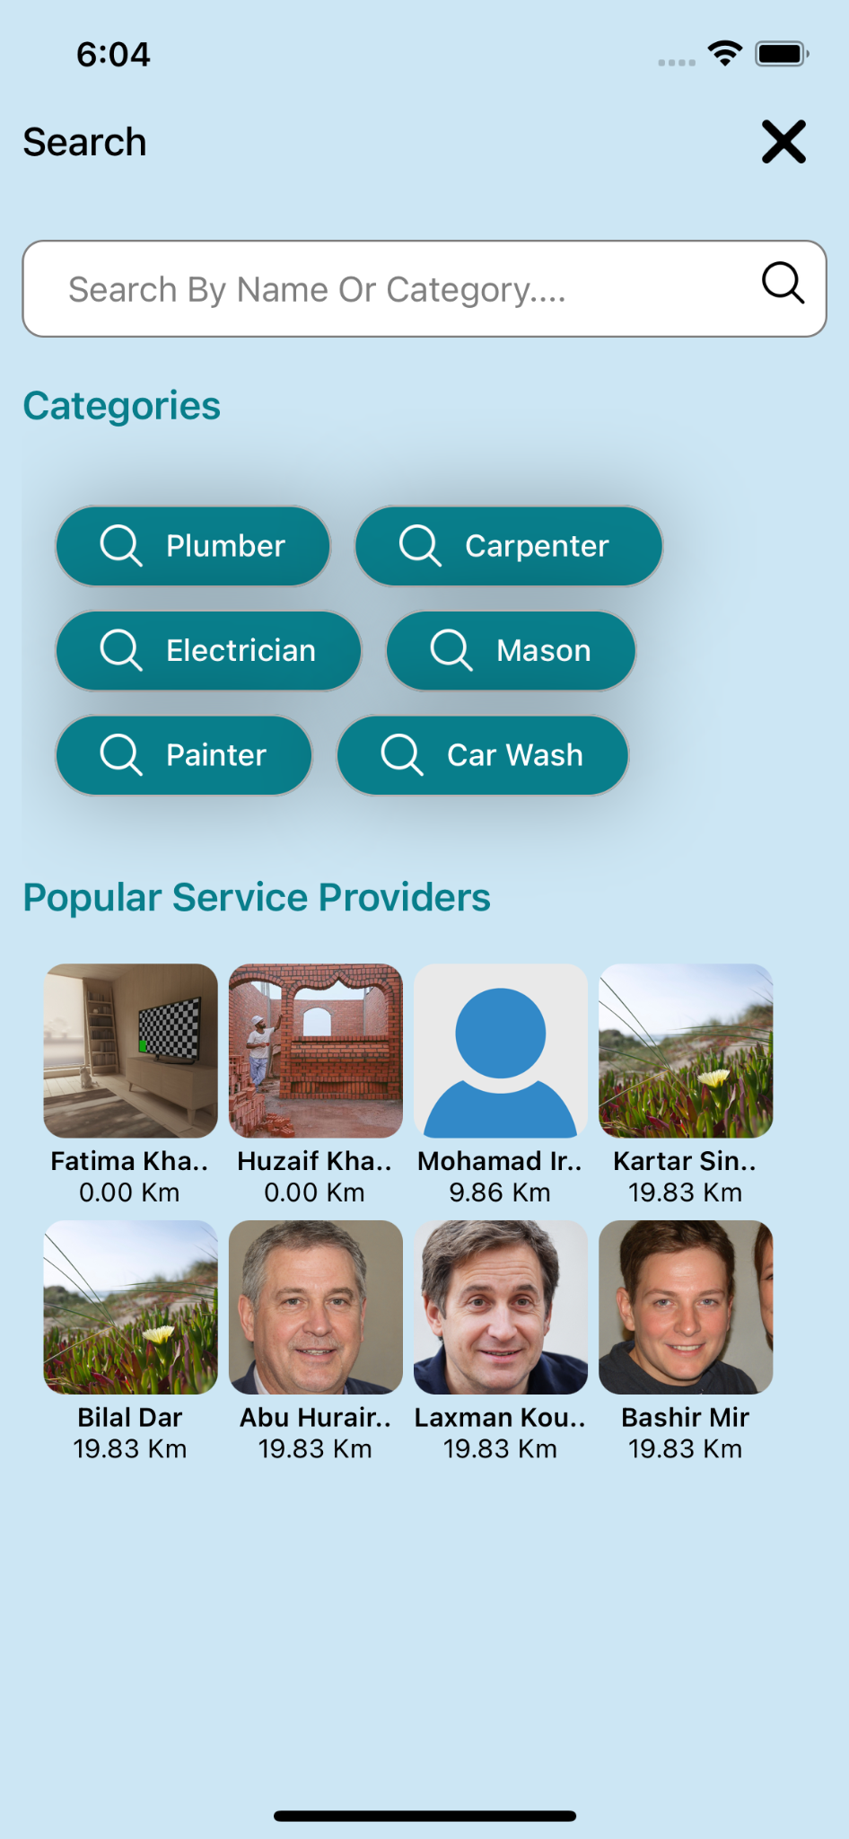

1. **Header**
   * The "Search" title on the top left
   * Close (X) button on the top right to exit the search screen
2. **Search Bar**
   * Located at the top of the screen
3. **Categories Section**
   * Displays common service categories
4. **Popular Service Providers Section**
   * Shows a grid of popular or nearby service providers

#### Search Bar

* A text input field at the top of the screen
* Placeholder text reads "Search By Name Or Category...."
* The magnifying glass icon on the right side of the search bar

#### Categories

The Categories section displays six common service categories in teal-colored buttons:

1. Plumber
2. Carpenter
3. Electrician
4. Mason
5. Painter
6. Car Wash

Each category button has a magnifying glass icon, indicating that tapping it will perform a search for that category.

#### Popular Service Providers

This section displays a grid of service providers, showing:

* Provider's profile picture
* Provider's name
* Distance from the user's location

The grid shows 8 service providers:

1. Fatima Kha... (0.00 Km)
2. Huzaif Kha... (0.00 Km)
3. Mohamad Ir... (9.86 Km)
4. Kartar Sin... (19.83 Km)
5. Bilal Dar (19.83 Km)
6. Abu Hurair... (19.83 Km)
7. Laxman Kou... (19.83 Km)
8. Bashir Mir (19.83 Km)

#### How to Use the Search Screen

1. **Text Search**
   * Tap the search bar at the top
   * Type in a service provider's name or a category
   * Press the search icon or Enter to see the results
2. **Category Search**
   * Tap on any of the category buttons (e.g., Plumber, Carpenter) to see service providers in that category
3. **Browse Popular Providers**
   * Scroll through the Popular Service Providers section
   * Tap on a provider's profile to view more details or book their services
4. **Close Search**
   * Tap the X button in the top right corner to exit the search screen and return to the previous screen

#### Additional Notes

* The distances shown for service providers indicate how far they are from your current location
* Some provider names are truncated due to space limitations (indicated by "...")
* The search functionality likely includes both service categories and provider names, allowing for flexible searching

### **4.11 Screen List Layout**

### 

#### Search Results Screen

This screen displays the results of a search query, showing service providers that match the search criteria.

#### Screen Layout

1. **Header**
   * "Search" title on the top left
   * Close (X) button on the top right to exit the search screen
2. **Search Bar**
   * Located at the top of the screen, populated with the search query
3. **Search Results**
   * A list of service providers matching the search criteria

#### Search Bar

* Shows the current search query: "plumber"
* An "X" button on the left to clear the search
* A magnifying glass icon on the right to initiate a new search

#### Search Results

The results are displayed as a list of cards, each representing a service provider. Each card contains:

1. **Provider Information**
   * Profile picture
   * Name of the service provider
   * Distance from the user's location
   * Service category (Plumber in this case)
   * Availability status
2. **Available Dates**
   * Three teal-colored buttons showing available dates: 12 Jul, 13 Jul, 14 Jul
3. **Booking Option**
   * A "Book Now" button to initiate the booking process

#### Displayed Results

The search for "plumber" returned four results:

1. Ubaid
   * 0 Km away
   * No profile picture (default icon shown)
2. Abdul Mir
   * 19.83 Km away
   * Profile picture displayed
3. Rashid Mir
   * 19.83 Km away
   * Profile picture displayed
4. Bashir Mir
   * 19.83 Km away
   * Profile picture displayed

All providers are listed as "Available" and show the same available dates.

#### How to Use the Search Results Screen

1. **Refine Search**
   * Tap the search bar to modify your search query
   * Use the "X" in the search bar to clear the current search
   * Tap the magnifying glass icon to perform a new search
2. **View Provider Details**
   * Each card provides a quick overview of the service provider
   * Note the distance to help choose a nearby provider
3. **Check Availability**
   * The date buttons (12 Jul, 13 Jul, 14 Jul) indicate when the provider is available
   * These dates likely correspond to the next three days from the current date
4. **Book a Service**
   * To book a service with a particular provider, tap the "Book Now" button on their card
   * This will likely take you to a booking screen for that specific provider
5. **Exit Search**
   * Tap the X button in the top right corner to exit the search results and return to the main screen

#### Additional Notes

* The search results are likely sorted by proximity, with the closest provider (Ubaid at 0 Km) listed first
* All providers shown are categorized as "Plumber", matching the search query
* The consistent availability across all providers suggests these might be the next three available days, rather than provider-specific availability

## **5. Advanced Features**

### **5.1 Adding and Managing Locations**

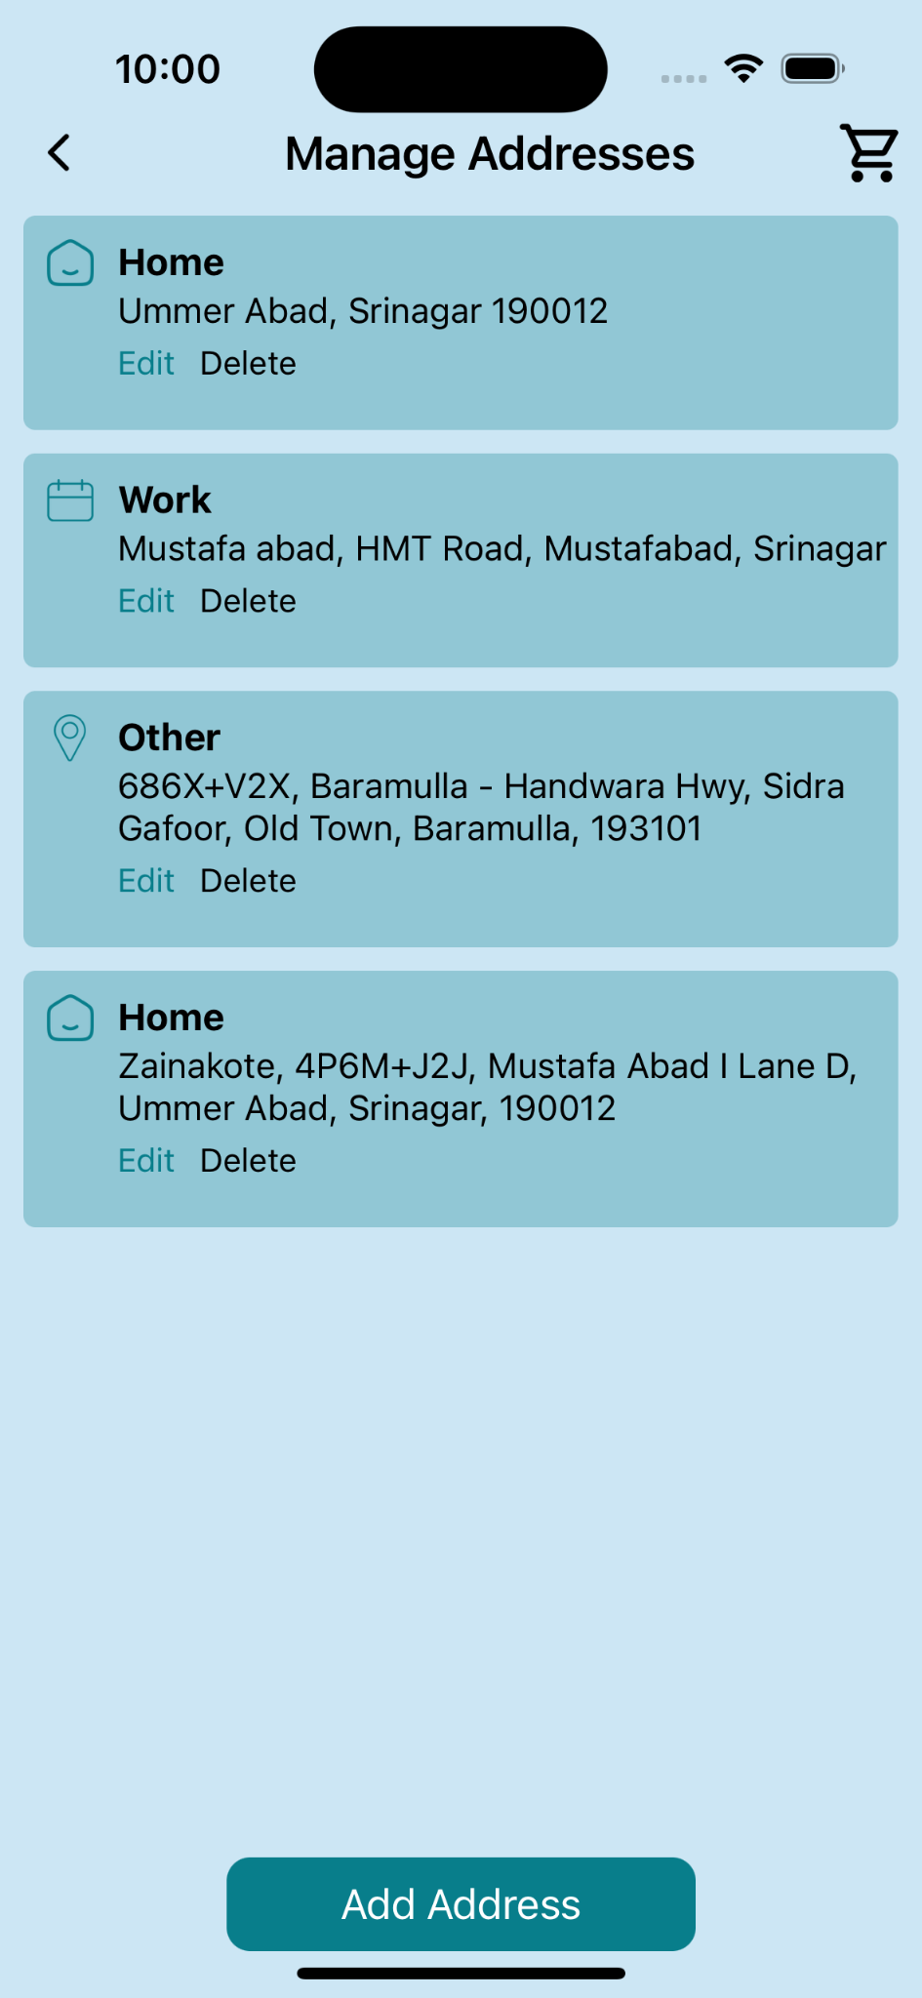

Mehanti allows you to save multiple locations for easy booking. This is particularly useful if you frequently need services at different addresses (e.g., home, office, vacation property).

#### **Adding a New Location**

#### 

1. Go to your Profile.
2. Find the "Manage Locations" or "Saved Locations" section.
3. Tap "Add New Location".
4. You can either:
   * Enter the address manually
   * Use your current location
   * Drop a pin on the map
5. Give your location a name (e.g., "Home", "Office").
6. Add any additional details that might help service providers (e.g., "Blue house with white fence").
7. Tap "Save" to add the new location.

#### **Editing or Deleting Locations**

1. In the "Manage Locations" section, find the location you want to modify.
2. Tap the "Edit" icon (usually a pencil) to make changes.
3. To delete, look for a trash can icon or a "Delete" option.

#### **Setting a Default Location**

1. In your locations list, find your preferred default location.
2. Look for a "Set as Default" option.
3. This location will now be pre-selected when booking services.

## 6. **Frequently Asked Questions**

## 7. **Contacting Support**

## 

## 